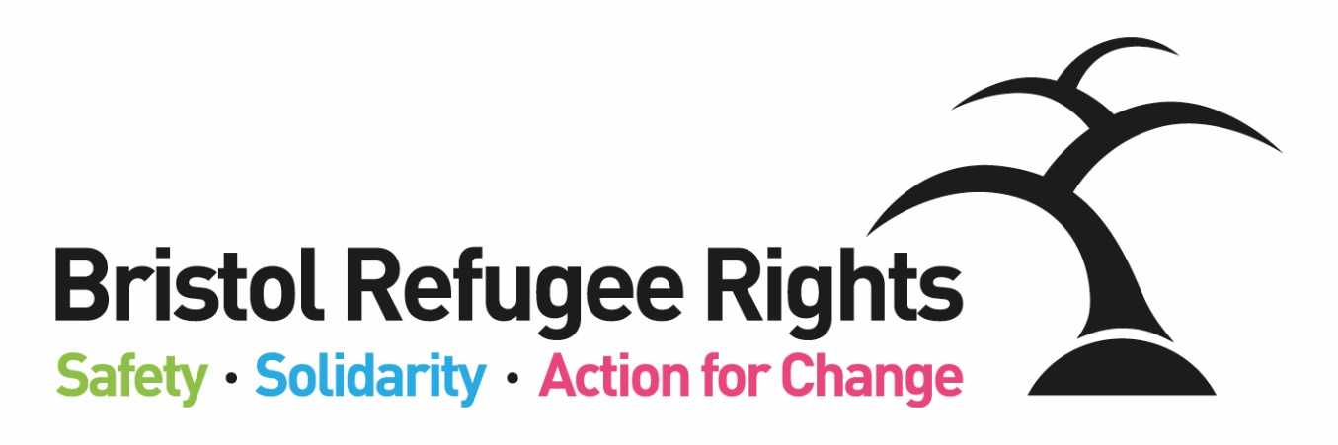

Advice Team Assistant

Recruitment Pack
August 2019

Dear Applicant
Advice Team Assistant
Thank you for expressing an interest in the post of Advice Team Assistant. This is a new post and we are looking for an organised person with good communication skills who can assist our very busy Advice Team – particularly helping to support our valued team of volunteers. This is a fixed term post – due to end on 31st March 2019.
Bristol Refugee Rights is a charity that has been running since 2006. Our vision is:
A society where refugees, asylum seekers and migrants are welcomed, feel safe, live free of poverty and are able to positively build their lives. A society where everyone’s rights and entitlements are respected.
We work to fulfil this vision through the delivery of unique, direct services to asylum seekers, refugees and some other migrants. We provide a place for asylum seekers and new refugees to meet, obtain advice, receive practical and emotional support and find ways to meet and engage with the wider community. Asylum seekers and refugees commonly experience isolation, deprivation, poverty and social exclusion combined with the implications of negative stereotyping. BRR aims to counter such difficulties through the provision of direct services, a warm welcome, a sense of belonging and the building of trust. One of our members said:
“They have been so helpful to me and the staff here are so welcoming and friendly. Great place to be.”
BRR is visited by around 200 asylum seekers and refugees (our members) each week. We are open 3 days a week, offering a range of services; Advice, English Classes, a Community Crèche, activities, a nourishing hot meal, free clothing and food parcels, arts and crafts. All of our services are delivered by 100+ strong diverse volunteer team (both member and non-member volunteers) and an able staff team. We are committed to ensuring our members guide, shape and drive BRR’s work and priorities, wherever possible, which we believe gives our organization a unique atmosphere. What makes BRR unique is the range of complementary services which BRR offers. Staff, volunteers, members and Trustees work together to achieve this. One of our partner organisations said:

‘There is no other group doing what BRR do in the South West. They plug the lacuna. Their services are absolutely vital and specialist.’

You can find out more about the work of BRR from our website and from our most recent Impact Report or feel free to contact me if you want to find out more.

If you feel that you could positively contribute to our work we would very much like to receive an application from you.

Yours faithfully

Beth Wilson, Director
Bristol Refugee Rights’ Aims and Ways of Working
EMPOWERMENT
EARLY ACTION
ADVOCACY
Safety – Solidarity – Action for Change

We work in partnership with others to combat poverty and destitution and to promote social and legal justice:
We will use an EARLY ACTION approach to working with asylum seekers, refugees and migrants; we will focus on preventing and de-escalating crises through the provision of good quality, early advice, support and information using methods which build resilience, support networks and well-being; as an organisation we will provide stability and strive for sustainability.
We empower people; promote inclusion and equality of opportunity through the breaking down of societal barriers:
We will EMPOWER asylum seekers, refugees and migrants by giving them information and confidence to access their rights and entitlements and to build their lives; asylum seekers, refugees and migrants will have opportunities to develop and share their talents; we will provide support for them to learn and develop personal and professional transferable skills through a range of opportunities both within and outside of the organisation.
We ensure the rights and entitlements of asylum seekers, refugees and migrants are respected:
We use ADVOCACY to challenge injustice for individuals, and for all asylum seekers, refugees and migrants; members will receive high quality and timely advice aimed at achieving their rights and entitlements and a fair outcome; we will lead and support campaigns for better treatment and for a fairer society; we will never accept the status quo.
Bristol Refugee Rights Values
- Respect: We are committed to equality and treating everyone fairly.
- Shared humanity: We are all human beings; we are all global citizens.
- Integrity: We have strong moral principles and act in the interests of people we work with.
- Collaboration: We build, support and encourage partnerships between individuals, teams and organisations.
- Empowerment: We encourage people to be stronger, more confident and to claim their rights.
- Innovation: We are adaptable, respond to the changing world around us and strive to be the best we can.
ADVICE TEAM ASSISTANT – Job Description

Hours of Work: | 15 hours per week (to include Wed and Thurs) (fixed term until 31st March 2019)
Salary: | £8065 pro-rata (£19,945 FTE – NJC Point 8)
Place of Work: | Malcolm X Community Centre and St Pauls Learning Centre, Central Bristol.
Responsible to: | Casework & Volunteer Coordinator

Purpose of job:
Assist the Casework & Volunteer Coordinator to recruit, train and support of Advice volunteers.
To provide support to the staff and volunteers in the Advice Team.

Specific Duties
- Support the recruitment, selection, induction and training process of Advice team volunteers (working with the Volunteer & Casework Coordinator).
- Follow up to volunteer recruitment, including obtaining references, DBS forms and contact details
- Support volunteers by seeking and receiving feedback and carrying out 1:1s (at least 2 x per year).
- Administrative and IT support for the team.
- Supporting data entry into the Lamplight Database by team volunteers.
- Helping to compile requirements/policies for funding bids, reports and advice standards quality marks
BRR General Duties
- Encourage the involvement of members and volunteers in all relevant aspects of planning and running the Welcome Centre.
- Provide support where appropriate to BRR campaigns.
- Provide information from the Advice Team to assist BRR’s social policy and campaigning work.
- Work within the wider staff team of BRR, attend staff meetings, contribute to good communications between staff, volunteers and members and participate in training opportunities appropriate to the post.
- Work within BRR’s aims, objectives and policies, take appropriate responsibility for health & safety at the Welcome Centre within the relevant legislative and BRR policy frameworks, and for protection of BRR’s property and premises from misuse, damage and theft.
- Promote equality and rights for asylum seekers, model positive behaviour and implement BRR’s equal opportunities policy.
- Carry out additional duties in consultation with the line manager as are consistent with the responsibilities of the post. Occasional evening and weekend working may be required by prior arrangement.
ADVICE TEAM ASSISTANT – Person Specification

Essential Criteria
Experience
- Work experience – paid or voluntary – with asylum seekers or refugees
- Experience of volunteering (either volunteering or working with volunteers)
- At least one year experience of working in administration
Knowledge and Approach
- Ability to work as part of a team and under supervision
- Knowledge of the experience of asylum seekers and new refugees in the UK and a commitment to working with them
- An understanding of the current asylum process in the UK
- Understanding of and commitment to equality, diversity and inclusion
- Ability to work well with people from a wide range of countries, faiths and backgrounds
- Understanding of and commitment to the vision, mission statement, values and objectives of BRR
- An understanding of, and commitment to, safeguarding children and adults
Skills
- Ability to supervise and support volunteers effectively
- Good communication skills: written and verbal in English, and an ability to work in a culturally and linguistically diverse community setting
- Ability to work independently on own initiative, and as part of a team
- Organisational and time management skills, ability to prioritise tasks and work under pressure and to deadlines
- Administrative skills e.g. maintenance of records, managing petty cash, writing reports, minutes, leaflets to promote service
- IT literacy

Desirable Criteria
- Experience of volunteer recruitment and/or management
- Direct experience of the asylum process
- Fluency in at least one relevant language (Arabic, Farsi, Mandarin, Pashto, Somali, Kurdish Sorani, Tigrinya)
- Understanding of work in the voluntary sector
- An awareness of health and safety issues
- Understanding of the requirements of data protection

