BRR is Moving Newsletter 1 – March 2020
So, in case you haven’t heard, we wanted to tell you that BRR is moving. The aim of this Newsletter (and others planned over the next few weeks) is to tell you what is happening and keep you informed as our plans develop.

Why is BRR moving:
As you may be aware, BRR has been on the look out for a new premises for many years. There are a number of reasons for this:
- We wanted to find somewhere that we could stay long term; that would allow us to expand and contract more easily.
- We needed more office space and space for Interview rooms for advice and other individual support.
- We wanted to be in a location with other partner organisations.
We have searched the city high and low for many years and feel that we have finally found our new home.

Where:
BRR is moving to the recently merged Wellspring Settlement (formerly Wellspring Healthy Living Centre and Barton Hill Settlement). We will be mainly based on what was the Barton Hill Settlement site (now called the Ducie Road Site). The location has good transport links (it is near to buses on Church road and to Lawrence Hill Train Station) and should be easy to access on foot/bike for many members who live in the BS5 area.

How:
We’ll be moving our offices and interview rooms into a new building at Wellspring Settlement currently under construction called the Micro-Settlement (see the picture at the top of this sheet). This is based at the back of the Ducie Road site (formerly Barton Hill Settlement) running along Morton Street on what used to be a derelict area/car park. We will have 6 of the ground floor units you can see (purple to red) and in this space we will have 3 offices; 4 interview rooms; a classroom/meeting room and a waiting area. Staff and volunteers will use this as a hub for delivering advice and other services such as destitution support. The layout will look quite close to this:
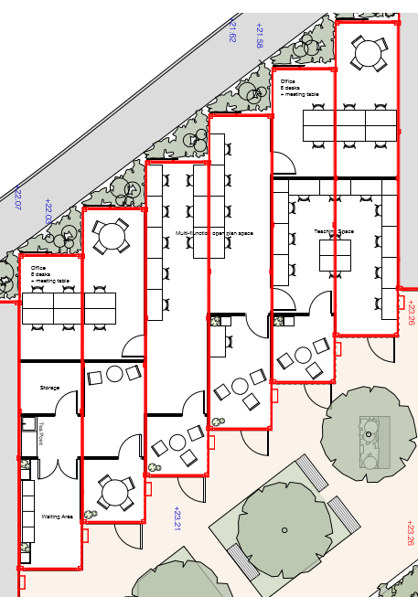
We will also be using the Ducie Road site hall (formerly the Barton Hill Settlement Hall) as our Main Hall; some classrooms in the settlement for our classrooms and the creche room at the Beam Street Site (formerly the Wellspring Centre).

When:
Because the offices etc within the Containers are still under construction we don’t have a definite moving date yet. The work has been hampered in recent weeks by wind and rain and we’re keeping fingers crossed for better weather and that there won’t be any impact as a result of Coronavirus. With all that in mind, we are hoping to move everything towards the end of April.

Will BRR be closed during the move:
We will have to close for at least 1 week in order to move and possibly for 2 weeks. This will give the staff time to pack, move, unpack and get everything ready for our first day when members visit us.

If the building work progresses as hoped, the closure week(s) will fall during Ramadan which is often a quieter time of the year for us anyway. We are currently in discussions with partner organisations about putting some additional support in place from other places during the closure time as we want to minimise the impact on members.

Will services be the same at Wellspring Settlement as they are now:
At the moment, we are trying to keep things as much the same as possible after the move. This means we will still definitely have the big hall on a Wednesday, classes and a creche. We will still have a lunch on a Thursday with the Advice team running a triage.
However, there may have to be some small changes because the spaces at Wellspring Settlement will be different to what we have at the moment. We are working hard to minimise these as much as possible.

In the longer term there may be more changes as our new home presents us with opportunities to do things in a different way or we develop new partnerships. We will keep you informed as this develops and any big changes will be talked about before they happen at a Strategy Day which we hope to have later in the year.

Is there anything I can do to help?
We have had lots of offers of help which is fantastic. Because we have lots of stuff to move, we’ll be getting professional movers to help us with the actual move.

We’ll let you know if there is anything we need help with as we get closer to the move. One thing you could do, is start taking your donations for the Free Shop to ABC instead of us as we’re not expecting to have space for them at Wellspring Settlement.

Who can I contact if I need more information?
If you’re a volunteer, you could speak to a Coordinator before or after your shift. Otherwise you can contact any of the Strategic Management Team:
Beth (Director) beth@bristolrefugeerights.org
Alice (Welcome Manager) alice@bristolrefugeerights.org
Elinor (Advice Manager) elinor@bristolrefugeerights.org
Sally (Office Manager) sally@bristolrefugeerights.org
Ruth (Fundraising and Communications Manager) ruthsj@bristolrefugeerights.org

We plan to regular produce a Newsletter to keep people updated as the move progresses so if you have anything in particular you want us to include, please let us know.

