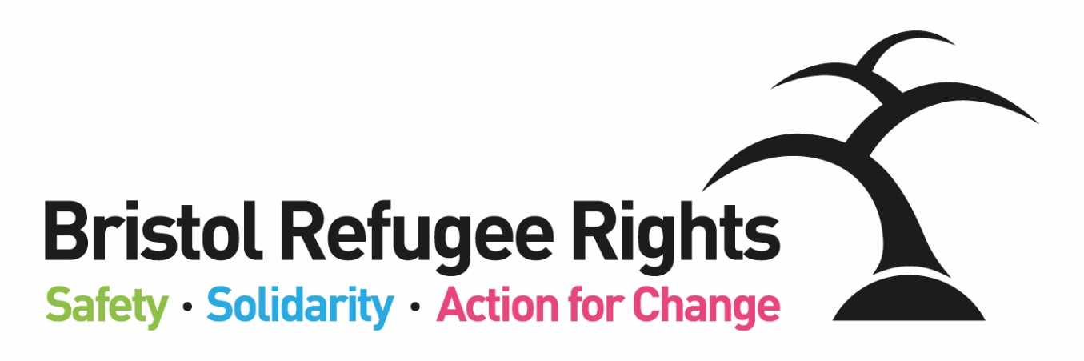

Individual Giving Fundraiser

Recruitment Pack
September 2021

Dear Applicant
Individual Giving Fundraiser
Thank you for expressing an interest in this post. This post is a new role that has been developed to work as part of our Fundraising Team. The successful candidate will be responsible for managing and growing our individual giving, managing relationships with our regular givers, community fundraisers and one off donors across a range of giving platforms. They will also manage fundraising and advocacy communications across a range of digital channels. The role will give scope to develop existing fundraising and communication skills and will provide opportunities to learn alongside a highly respected team of staff who are well networked locally and nationally.
We think BRR is a great place to work and we are able to offer a number of benefits including: flexible working; workplace pension scheme and access to a bike scheme.
Bristol Refugee Rights is a charity that has been running since 2006. Our vision is:
A society where refugees, asylum seekers and migrants are welcomed, feel safe, live free of poverty and are able to positively build their lives. A society where everyone’s rights and entitlements are respected.
We work to fulfil this vision through the delivery of unique, direct services to asylum seekers, refugees and some other migrants. We provide a place for asylum seekers and new refugees to meet, obtain advice, receive practical and emotional support and find ways to meet and engage with the wider community. Asylum seekers and refugees commonly experience isolation, deprivation, poverty and social exclusion combined with the implications of negative stereotyping. BRR aims to counter such difficulties through the provision of direct services, a warm welcome, a sense of belonging and the building of trust. One of our members said:
“They have been so helpful to me and the staff here are so welcoming and friendly. Great place to be.”
BRR is currently offering a range of services including; Advice, English Classes, Family activities. All of our services are delivered by a strong diverse volunteer team (both member and non-member volunteers) and an able staff team. We are committed to ensuring our members guide, shape and drive BRR’s work and priorities, wherever possible, which we believe gives our organization a unique atmosphere. What makes BRR unique is the range of complementary services which BRR offers. Staff, volunteers, members and Trustees work together to achieve this. One of our partner organisations said:
‘There is no other group doing what BRR do in the South West. They plug the lacuna. Their services are absolutely vital and specialist.’
You can find out more about the work of BRR from our website and from our most recent Impact Report or feel free to contact me if you want to find out more. If you feel that you could positively contribute to our work we would very much like to receive an application from you.

Yours faithfully
Beth Wilson, Director
Bristol Refugee Rights’ Aims and Ways of Working
EMPOWERMENT
EARLY ACTION
ADVOCACY
Safety – Solidarity – Action for Change

We work in partnership with others to combat poverty and destitution and to promote social and legal justice:
We will use an EARLY ACTION approach to working with asylum seekers, refugees and migrants; we will focus on preventing and de-escalating crises through the provision of good quality, early advice, support and information using methods which build resilience, support networks and well-being; as an organisation we will provide stability and strive for sustainability.
We empower people; promote inclusion and equality of opportunity through the breaking down of societal barriers:
We will EMPOWER asylum seekers, refugees and migrants by giving them information and confidence to access their rights and entitlements and to build their lives; asylum seekers, refugees and migrants will have opportunities to develop and share their talents; we will provide support for them to learn and develop personal and professional transferable skills through a range of opportunities both within and outside of the organisation.
We ensure the rights and entitlements of asylum seekers, refugees and migrants are respected:
We use ADVOCACY to challenge injustice for individuals, and for all asylum seekers, refugees and migrants; members will receive high quality and timely advice aimed at achieving their rights and entitlements and a fair outcome; we will lead and support campaigns for better treatment and for a fairer society; we will never accept the status quo.
Bristol Refugee Rights Values
- Respect: We are committed to equality and treating everyone fairly.
- Shared humanity: We are all human beings; we are all global citizens.
- Integrity: We have strong moral principles and act in the interests of people we work with.
- Collaboration: We build, support and encourage partnerships between individuals, teams and organisations.
- Empowerment: We encourage people to be stronger, more confident and to claim their rights.
- Innovation: We are adaptable, respond to the changing world around us and strive to be the best we can.
Individual Giving Fundraiser
Hours of Work: | 30 hours per week
Salary: | Scale 6 – points 18-23 (starting salary of £20,256 - pro rata to FTE of £24,982)
Place of Work: | Wellspring Settlement/Home Working
Responsible to: | Fundraising Manager
Responsible for: | Fundraising and Communications Volunteers
Purpose of job:
- Be accountable for Individual Giving income, monitoring, reporting and evaluating results with the Fundraising Manager in order to review, grow and deliver increased voluntary income and regular donations
- Manage relationships with regular givers, community fundraisers and one off donors across a range of giving platforms
- Contribute to BRR’s overall Income Generation Strategy as a member of the Fundraising Team
- Manage fundraising and advocacy communications across a range of digital media platforms

Specific Duties and Responsibilities
- Work with the Fundraising Manager
  - to develop and review individual giving strategies and plans in line with strategic objectives
  - to review and oversee individual giving administration processes and develop and formalise donor management systems
- Donor care and engagement
  - day-to-day responsibility for managing relationships and communications with existing supporters to ensure a high level of donor care
  - Manage and develop the use of BRR’s CRM effectively to segment data and make insight-led decisions
- Administration:
  - manage individual giving administration ensuring that all donations and income is correctly recorded, tracked and thanked
  - to provide data and insight to identify HNWI (High Net Worth Individual) and potential Major Donors
  - analyse and report on fundraising activities, including post-campaign evaluations and future recommendations for activities
  - Understand and stay informed with developments around data protection and Gift Aid
- Fundraising Team
  - To engage BRR members (service users) in BRR fundraising and communications work as appropriate
  - Be responsible for recruitment, supervision and support of any volunteers involved in individual giving campaigns and activities including website and social media.
  - Support and grow individual community fundraisers
  - Build strong and lasting relationships with a wide range of internal and external stakeholders including representing BRR in outreach to corporates and manage relationships
  - Work with all BRR colleagues to ensure that individual giving activity is integrated and aligned with the overall organisation and fundraising strategies
  - Work with Finance in relation to donor reporting and banking
- Communications
  - Devise and implement online individual giving campaigns including crowdfunders and working with social media influencers to drive income and ensuring diversity is embedded in all communications
  - Coordinate BRR’s external communication including website developments, blog and social media posts.
BRR General Duties
- Work within the wider staff team of BRR, attend appropriate meetings, contribute to good communications between staff, volunteers and members and participate in training opportunities appropriate to the post.
- Work within BRR’s aims, objectives and policies. Promote equality and rights for asylum seekers, model positive behaviour and champion BRR’s equal opportunities policy.
- Take appropriate responsibility for safeguarding and health & safety within the relevant legislative and BRR policy frameworks.
- Carry out additional duties in consultation with the line manager as are consistent with the responsibilities of the post. Occasional evening and weekend working may be required by prior arrangement.
Individual Giving Fundraiser
Essential Criteria
Experience
- Relevant charity fundraising experience with understanding of supporter acquisition and retention, supporter journey development and motivations for giving
- Practical experience of using a CRM database to support donor management
- Successful track record of generating income and achieving targets
- Experience of developing fundraising and communications initiatives
- Proven ability to engage and inspire individuals to donate, with an excellent understanding of online giving and digital channels
Knowledge and Approach
- Demonstrably creative and imaginative approach towards devising fundraising campaigns
- Knowledge of fundraising through digital platforms
- Good understanding of the principles of fundraising, and familiarity with the Code of Fundraising Practice
- A commitment to undertake training where required and an enthusiasm for new challenges and experiences
- An understanding of the requirements of data protection and confidentiality
- Understanding of and commitment to equality, diversity and inclusion
- Ability to work well with people from a wide range of countries, faiths and backgrounds
- Understanding of and commitment to the vision, mission statement, values and objectives of BRR
- Awareness of, and commitment to, safeguarding children and adults
Skills
- Excellent communication skills: written and verbal in English, and an ability to work in a culturally and linguistically diverse community setting
- Excellent relationship management skills, with ability to motivate others
- Organisational and time management skills, ability to prioritise tasks and work under pressure and to deadlines
- Good interpersonal skills with the ability to build rapport and communicate sensitively; negotiating effectively to generate support among people from diverse backgrounds
- Good administrative skills and attention to detail
- Strong analytical and methodical IT skills with experience of CRM, Word, Excel, PowerPoint, Outlook

Desirable Criteria
- Knowledge of the experience of asylum seekers and new refugees in the UK and a commitment to working with them
- Experience of working to develop strategic and operational income generation plans
- Experience of volunteer recruitment and/or management
- Direct experience of the asylum or immigration system – either through working in the sector or lived experience
