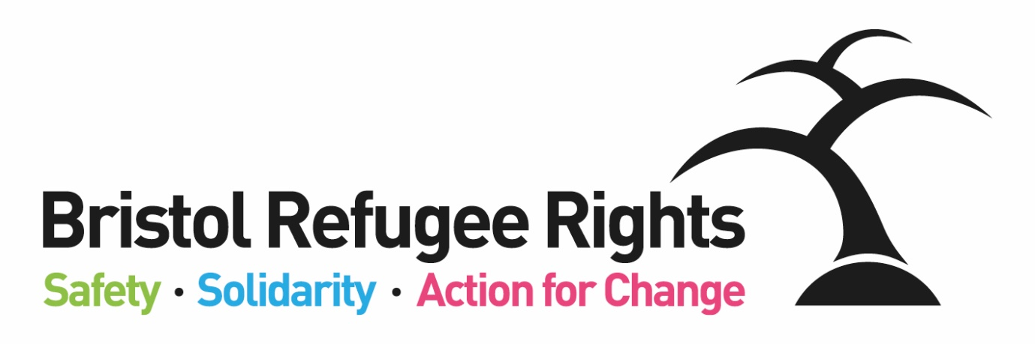

Advice Worker

Recruitment Pack
February 2023

Dear Applicant
Thank you for expressing an interest in the post of Advice Worker. BRR’s Advice Team provides specialist advice in Bristol for people needing to claim asylum, who have an asylum claim pending, or who have been refused asylum. Staff members support a team of volunteers in carrying out this advice work. This post is offered on a 1 year fixed term contract.
Most of our casework involves:
- Assessing asylum or immigration status in order to advise people of rights and options for financial support or accommodation
- Home Office asylum support entitlements and associated problems
- Referring clients to appropriate legal advice where possible
- Work to support access to legal representation – eg. Subject Access Requests to the Home Office or Exceptional Case Funding applications
- Referrals to and liaison with Social Services and healthcare providers.
Many of our clients are homeless and destitute, and we work closely with voluntary and statutory sector partners to alleviate destitution, and provide advice and casework to support people to realise their rights and entitlements.
Whilst we would like the new post holder to have knowledge of UK immigration and/or asylum systems, we do not require specialist knowledge of Home Office asylum support rights and processes, as training can be provided. We think BRR is a great place to work and we are able to offer a number of benefits including: flexible working; workplace pension scheme and access to a bike scheme.
Bristol Refugee Rights is a charity that has been running since 2006. Our vision is:
A society where refugees, asylum seekers and migrants are welcomed, feel safe, live free of poverty and are able to positively build their lives. A society where everyone’s rights and entitlements are respected.
We work to fulfil this vision through the delivery of unique, direct services to asylum seekers, refugees and some other migrants. We provide a place for asylum seekers and new refugees to meet, obtain advice, receive practical and emotional support and find ways to meet and engage with the wider community. Asylum seekers and refugees commonly experience isolation, deprivation, poverty and social exclusion combined with the implications of negative stereotyping. BRR aims to counter such difficulties through the provision of direct services, a warm welcome, a sense of belonging and the building of trust. One of our members said:
“They have been so helpful to me and the staff here are so welcoming and friendly. Great place to be.”
BRR offers a range of services including; Advice, a social drop-in, English Classes, Family activities. All of our services are delivered by a strong diverse volunteer team (both member and non-member volunteers) and an able staff team. We are committed to ensuring our members guide, shape and drive BRR’s work and priorities, wherever possible, which we believe gives our organization a unique atmosphere. What makes BRR unique is the range of complementary services which BRR offers. Staff, volunteers, members and Trustees work together to achieve this. One of our partner organisations said:

‘There is no other group doing what BRR do in the South West. They plug the lacuna. Their services are absolutely vital and specialist.’

You can find out more about the work of BRR from our website and from our most recent Impact Report or feel free to contact me if you want to find out more.

If you feel that you could positively contribute to our work we would very much like to receive an application from you.

Yours faithfully

Bristol Refugee Rights
Bristol Refugee Rights’ Aims and Ways of Working
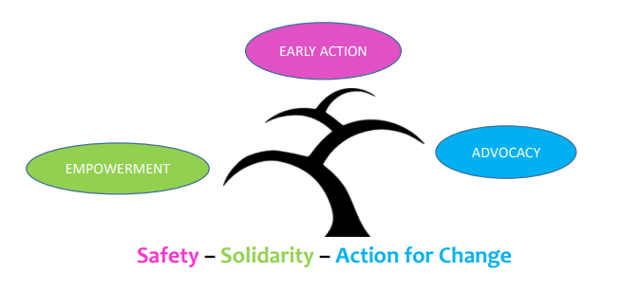
We work in partnership with others to combat poverty and destitution and to promote social and legal justice:
We will use an EARLY ACTION approach to working with asylum seekers, refugees and migrants; we will focus on preventing and de-escalating crises through the provision of good quality, early advice, support and information using methods which build resilience, support networks and well-being; as an organisation we will provide stability and strive for sustainability.
We empower people; promote inclusion and equality of opportunity through the breaking down of societal barriers:
We will EMPOWER asylum seekers, refugees and migrants by giving them information and confidence to access their rights and entitlements and to build their lives; asylum seekers, refugees and migrants will have opportunities to develop and share their talents; we will provide support for them to learn and develop personal and professional transferable skills through a range of opportunities both within and outside of the organisation.
We ensure the rights and entitlements of asylum seekers, refugees and migrants are respected:
We use ADVOCACY to challenge injustice for individuals, and for all asylum seekers, refugees and migrants; members will receive high quality and timely advice aimed at achieving their rights and entitlements and a fair outcome; we will lead and support campaigns for better treatment and for a fairer society; we will never accept the status quo.
Bristol Refugee Rights Values
- Respect: We are committed to equality and treating everyone fairly.
- Shared humanity: We are all human beings; we are all global citizens.
- Integrity: We have strong moral principles and act in the interests of people we work with.
- Collaboration: We build, support and encourage partnerships between individuals, teams and organisations.
- Empowerment: We encourage people to be stronger, more confident and to claim their rights.
- Innovation: We are adaptable, respond to the changing world around us and strive to be the best we can.

Job Description
Advice Worker

Hours of Work: | 30 hours per week (including Tues, Weds and Thurs)
Salary: | £22,170 - £24,446 per year (NJC points 18-23)  (Pro rata to FTE - £27,344 - £30,151 – NJC scale 6)
Contract: | 1 year fixed term contract
Place of Work: | Wellspring Settlement / home
Responsible to: | Advice Service Manager

Purpose of job:
- To deliver advice to members and provide support to volunteer advisers.
- Work with the Advice Service Manager to recruit, train and support Advice volunteers.
- Provide administrative support to the staff and volunteers in the Advice Team.

Specific duties
Advice and casework:
- Together with team colleagues and as agreed with the Advice Service Manager:
  - To co-ordinate advice casework
  - Work with team to allocate casework to volunteers
  - Attend weekly Advice Drop-In (by rota) to provide triage and advice
  - Respond to advice and casework queries and messages from clients and partner agencies
  - Undertake casework and liaison with clients, partners and statutory agencies, including attending relevant meetings on behalf of BRR
  - Record all casework on our casework database.
- Liaising effectively with BRR Safeguarding Leads to communicate concerns and work with them to complete any follow up required
- Contribute to service development, developing tools for Advice team and handout information.
Administration:
- Provide administrative and IT support for Advice volunteers
Volunteer support:
- Working with the Advice Volunteer Supervisor provide day to day support and case guidance for advice volunteers
- Contribute to and support briefing and debriefing meetings with staff and volunteers
- Provide support and updates to volunteers as needed
- Support the recruitment, induction and training of Advice team volunteers

BRR General Duties
- Encourage the involvement of members and volunteers in all relevant aspects of planning and running the service.
- Provide support where appropriate to BRR campaigns.
- Provide information from the Advice Team to assist BRR’s social policy and campaigning work.
- Work within the wider staff team of BRR, attend staff meetings, contribute to good communications between staff, volunteers and members and participate in training opportunities appropriate to the post.
- Work within BRR’s aims, objectives and policies, take appropriate responsibility for health & safety at the Welcome Centre within the relevant legislative and BRR policy frameworks, and for protection of BRR’s property and premises from misuse, damage and theft.
- Promote equality and rights for asylum seekers, model positive behaviour and implement BRR’s equal opportunities policy.
- Carry out additional duties in consultation with the line manager as are consistent with the responsibilities of the post. Occasional evening and weekend working may be required by prior arrangement.
Person Specification
Advice Worker
Essential Criteria
Experience
- Advice experience and casework experience in any advice field
- Experience of supervising and supporting volunteers
- Experience of monitoring and reporting
Knowledge and Approach
- Demonstrable knowledge of immigration law or asylum processes
- Ability to work well with people from a wide range of countries, faiths and backgrounds
- Understanding of and commitment to the vision, mission statement, values and objectives of BRR
- A good understanding of data protection
- An understanding of health and safety
- An understanding of, and commitment to, safeguarding children and adults
Skills
- Excellent IT and database skills with demonstrable experience using databases in day to day work
- An ability to support others with using IT / databases
- OISC Level 1 accreditation (or willingness to work towards)
- A love of order and accuracy

Desirable Criteria
- Direct experience of the asylum or immigration system – either through working in the sector or lived experience
- Proficiency in a relevant language spoken by the refugee or immigrant communities in Bristol

