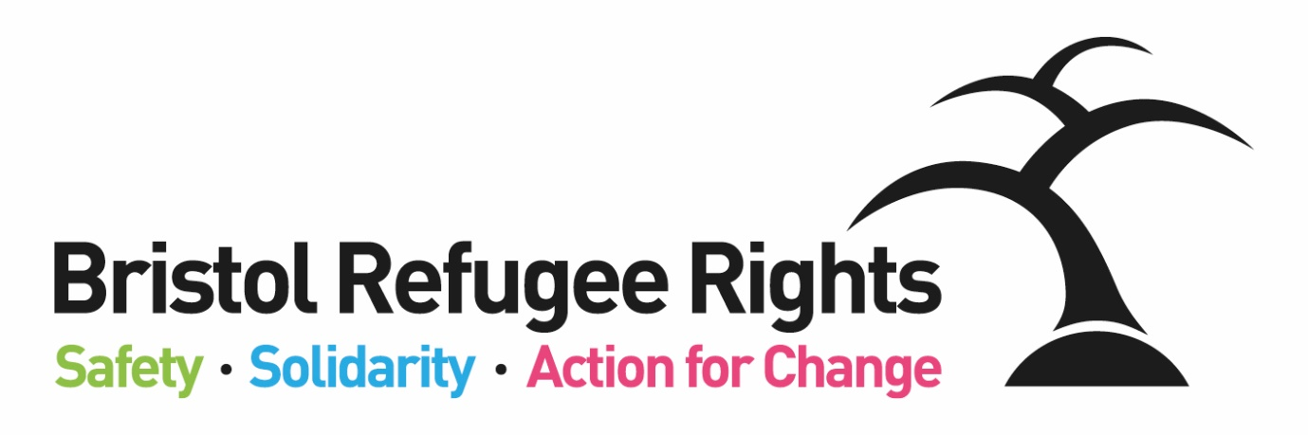

Welcome Team Assistant

Recruitment Pack
May 2023

Dear Applicant
Welcome Team Assistant
Thank you for expressing an interest in this job. This is a new role that will help the team at BRR to welcome members and help run our activities smoothly.
We think BRR is a great place to work and we are able to offer a number of benefits including: flexible working; workplace pension scheme and access to a bike scheme.
Bristol Refugee Rights is a charity that has been running since 2006. Our vision is:
A society where refugees, asylum seekers and migrants are welcomed, feel safe, live free of poverty and are able to positively build their lives. A society where everyone’s rights and entitlements are respected.
We work to fulfil this vision through the delivery of unique, direct services to asylum seekers, refugees and some other migrants. We provide a place for asylum seekers and new refugees to meet, obtain advice, receive practical and emotional support and find ways to meet and engage with the wider community. Asylum seekers and refugees commonly experience isolation, deprivation, poverty and social exclusion combined with the implications of negative stereotyping. BRR aims to counter such difficulties through the provision of direct services, a warm welcome, a sense of belonging and the building of trust. One of our members said:
“They have been so helpful to me and the staff here are so welcoming and friendly. Great place to be.”
BRR offers a range of services including; Advice, a social drop-in, English Classes, Family activities. All of our services are delivered by a strong diverse volunteer team (both member and non-member volunteers) and an able staff team. We are committed to ensuring our members guide, shape and drive BRR’s work and priorities, wherever possible, which we believe gives our organization a unique atmosphere. What makes BRR unique is the range of complementary services which BRR offers. Staff, volunteers, members and Trustees work together to achieve this. One of our partner organisations said:

‘There is no other group doing what BRR do in the South West. They plug the lacuna. Their services are absolutely vital and specialist.’

You can find out more about the work of BRR from our website and from our most recent Impact Report or feel free to contact me if you want to find out more.

If you feel that you could positively contribute to our work we would very much like to receive an application from you.

Yours faithfully

Bristol Refugee Rights
Bristol Refugee Rights’ Aims and Ways of Working
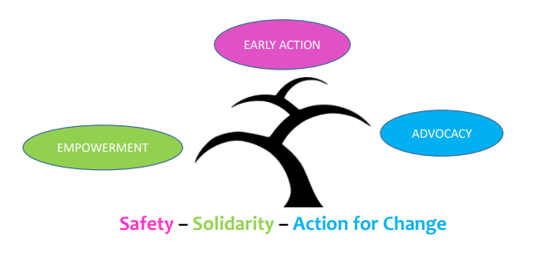
We work in partnership with others to combat poverty and destitution and to promote social and legal justice:
We will use an EARLY ACTION approach to working with asylum seekers, refugees and migrants; we will focus on preventing and de-escalating crises through the provision of good quality, early advice, support and information using methods which build resilience, support networks and well-being; as an organisation we will provide stability and strive for sustainability.
We empower people; promote inclusion and equality of opportunity through the breaking down of societal barriers:
We will EMPOWER asylum seekers, refugees and migrants by giving them information and confidence to access their rights and entitlements and to build their lives; asylum seekers, refugees and migrants will have opportunities to develop and share their talents; we will provide support for them to learn and develop personal and professional transferable skills through a range of opportunities both within and outside of the organisation.
We ensure the rights and entitlements of asylum seekers, refugees and migrants are respected:
We use ADVOCACY to challenge injustice for individuals, and for all asylum seekers, refugees and migrants; members will receive high quality and timely advice aimed at achieving their rights and entitlements and a fair outcome; we will lead and support campaigns for better treatment and for a fairer society; we will never accept the status quo.
Bristol Refugee Rights Values
- Respect: We are committed to equality and treating everyone fairly.
- Shared humanity: We are all human beings; we are all global citizens.
- Integrity: We have strong moral principles and act in the interests of people we work with.
- Collaboration: We build, support and encourage partnerships between individuals, teams and organisations.
- Empowerment: We encourage people to be stronger, more confident and to claim their rights.
- Innovation: We are adaptable, respond to the changing world around us and strive to be the best we can.

JOB DESCRIPTION
Welcome Team Assistant
Hours of Work: | 15 hours per week (Wednesday, Thursday)
Salary: | £8,524.89 per annum pro-rata for 15 hours (full time equivalent - £21,028)
Place of Work: | Wellspring Settlement, Bristol and/or home working
Responsible to: | Welcome Service Manager
Purpose of job:

To support Welcome Team activities and assist BRR members to access and navigate BRR’s services and be appropriately referred and signposted to other services.

Specific Duties and Responsibilities
Welcome Members:
- Welcome asylum seekers to BRR and help with registration and orientation
- Help to welcome members visiting BRR, support people waiting for services, refer members for appointments and manage expectations
- Invite members to Welcome Team activities and services and encourage participation
- Confidentially refer and signpost within BRR and to local partners and services
Support Welcome Team
- Support practicalities involved in delivering the weekly drop-ins, such as setting up rooms and provision of supplies and resources -explain procedures and guidelines for use of spaces
- Support volunteers working with food and help them to follow BRR’s Food Safety Policy
- Assist with monitoring and record keeping
- Support the team with Health and Safety checks
BRR General Duties
- Encourage the involvement of members and volunteers in all relevant aspects of planning and running Bristol Refugee Rights.
- Provide support where appropriate to BRR campaigns.
- Work within the wider staff team of BRR, attend appropriate meetings, contribute to good communications between staff, volunteers and members and participate in training opportunities appropriate to the post.
- Work within BRR’s aims, objectives and policies. Promote equality and rights for asylum seekers, model positive behaviour and champion BRR’s equal opportunities policy.
- Take appropriate responsibility for safeguarding and health & safety within the relevant legislative and BRR policy frameworks.
Carry out additional duties in consultation with the line manager as are consistent with the responsibilities of the post. Occasional evening and weekend working may be required by prior arrangement.
Welcome Team Assistant
Person Specification
Essential Criteria
Experience
- Direct experience of the asylum or immigration system – ideally through lived experience
- Experience of, or ability, to support people to access services
Knowledge and Approach
- Understanding of issues affecting asylum seekers and refugees
- Understanding of and commitment to equality, diversity and inclusion
- Ability to work well with people from a wide range of countries, faiths and backgrounds
- Enthusiastic, committed and willing to work as part of a team
- Be willing to undertake training as required
Skills
- Ability to communicate in a language spoken by the refugee or immigrant communities in Bristol
- Ability to communicate in English – both spoken and in writing
- Organisational and time management skills, ability to prioritise tasks and work under pressure and to deadlines
- Good administrative skills e.g. maintenance of records, managing petty cash
- IT literacy

Desirable Criteria
- Work experience – paid or voluntary – with asylum seekers/refugees
- Understanding of and commitment to the vision, mission statement, values and objectives of BRR
- Knowledge of how to work within professional boundaries
- Awareness of, and commitment to, safeguarding children and adults
- An awareness of health and safety issues
- An awareness of the requirements of data protection
- Food Hygiene Certificate or experience working in food service
