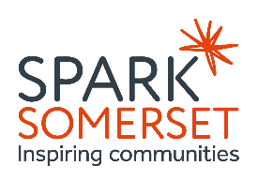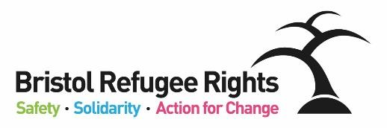

Somerset Welcome to All

Development Worker

Recruitment Pack

August 2025



Dear Applicant

Thank you for expressing an interest in the post of Somerset Welcome to All - Development Worker. This is an exciting new post that is being recruited by BRR to support our partnership work within the Somerset Welcome to All project. Please read all the information contained in here carefully – we will be holding information sessions where you can come along to ask any questions about this role (details in the job advert).

The Partnership has identified that it would benefit greatly from having people with lived experience of forced migration at the heart of what it does. We believe that lived expertise is valuable and should be at the forefront when designing services or responding to need, and that our sector should work more ‘with’ people and less ‘for’ and ‘to’ people who are displaced. To ensure this happens at all levels of the partnership we are setting up a Lived Experience Advisory Group (LEAG) who will form part of the Welcome to All Steering Group, and whose views will inform service design and partnership delivery.

There are various ways to describe people with lived experience – we use the following terms:

This role will support the LEAG and for this reason we are looking for an expert by experience to fill this role to ensure that the LEAG is properly supported and heard.

This role will be a development role – working closely with colleagues from BRR – we will ensure support and training is given to allow the Development Worker to thrive in the role. Over time the role will develop into managing the lived experience and training elements of the project, and supporting the partnership to ensure lived expertise shapes decisions.

The Partnership’s values and ways of working are set out below the job description and person specification further on in this document.

You can find out more about the work of BRR from our [website](https://www.bristolrefugeerights.org/about-us/jobs/) and from our most recent Impact Report or feel free to contact us if you want to find out more.

If you feel that you could positively contribute to our work we would very much like to receive an application from you.

Yours faithfully

**Somerset Welcome to All Partnership / Bristol Refugee Rights**

**This work has been commissioned by Somerset County Council with the following vision for the Welcome to All partnership:**

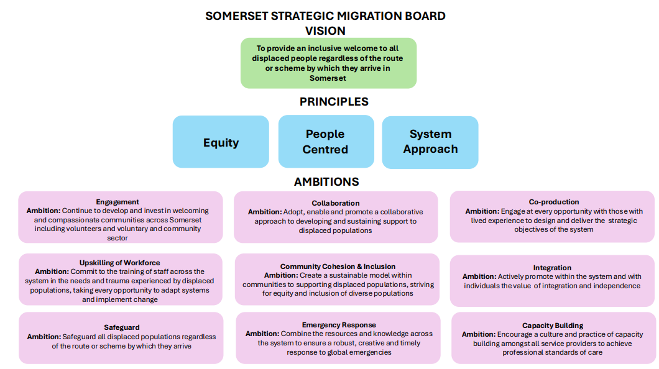

**Bristol Refugee Rights Values**

* ***Respect:***We are committed to equality and treating everyone fairly.
* ***Shared humanity:***We are all human beings; we are all global citizens.
* ***Integrity:***We have strong moral principles and act in the interests of people we work with.
* ***Collaboration:***We build, support and encourage partnerships between individuals, teams and organisations*.*
* ***Empowerment:***We encourage people to be stronger, more confident and to claim their rights.
* ***Innovation:***We are adaptable, respond to the changing world around us and strive to be the best we can.

**JOB DESCRIPTION**

**Somerset Welcome to All - Development Worker**

This role will be line-managed by Bristol Refugee Rights (BRR) but will be working in Somerset hosted by one of the Somerset Welcome Hubs partners.

This is a development role – this means this role will start on the initial pay scale but will work up to taking more responsibility on the project over time (likely within a year) with appropriate remuneration.

|  |  |
| --- | --- |
| **Hours of Work**: | 22.5 hours per week |
| **Contract:** | Initial contract – 1 year of development role, with expectation of extension to permanent |
| **Salary:** | £18,583 pro-rata (full time equivalent - £30,559) (NJC scale 6) |
| **Place of Work:** | This post will have a desk at SPARK near Taunton but will be a post that needs to travel between the different hubs and could also work from home. |
| **Benefits:** | Pension scheme, Cycle to Work Scheme, flexible working, hybrid working, Life Insurance, strong support structures |
| **Responsible to:** | BRR Development Manager at first, will be moved into the SPARK team in time |

**Purpose of job:**

To support with the development, creation and coordination of a Lived Experience Advisory Group (LEAG) across Somerset Welcome hubs.

To ensure that individuals with Lived experience are involved in shaping and creating services for displaced communities across Somerset Council.

Support development of training provision and delivery across the welcome hubs.

Work in partnership to encourage lived experience leadership across the sector.

To provide administrative support for the delivey of the advisory group and training provision.

**Specific Duties and Responsibilities**

**Lived Experience Advisory Group:**

* Work to support with the creation, promotion and recruitment of Lived Experience Groups representing Welcome hubs – this will involve working closely with BRR to organise meetings with the service users in the different hubs to promote the opportunity and recruit participants, and put efforts towards maintaining attendance levels.
* Coordinate representatives (volunteer service users) from each Hub, ensuring inclusive and accessible participation.
* Work closely with BRR to encourage active participation and co creation of the group through ongoing engagement and feedback.
* Once the LEAG is up and running, organise and facilitate Advisory Groups meetings, including meetings with local council stakeholders and follow up meetings with the advisory members.
* Work with the wider Somerset Welcome Partners to create opportunities for meaningful engagement for those on the lived experience advisory group, ensuring there are opportunities to shape services and have a key voice in the programme.
* Work closely with BRR to provide logistical and administrative support for LEAG meetings, including scheduling, preparing agendas, taking minutes and managing communication with the group members.
* Support the growth and development opportunities for lived-experience advisory group members, to ensure they are gaining valuable skills/experience as well as giving their skills/experience.
* Support the wellbeing of the lived-experience advisory group members.
* Attend the Strategic Steering Group meetings to support the LEAG members with attending, ensuring LEAG feedback and suggestions are taken to the meeting and support ensuring LEAG receives feedback about any actions taken and discussions held.

**Support development of training provision and delivery across the welcome hubs**

* Work closely with BRR, Spark, the Hubs and Somerset Welcome Partners to identify the training needs with a particular focus on people with lived experience and those from diverse communities.
* Provide administrative support for training activities including managing registration, booking venue, refreshments – in person or online platforms, sending reminders to participants.
* Assist in evaluating the impact of training and development activities.

**Partnership Work**

* Work in partnership with the Welcome Hubs, and other parts of the Somerset Welcome to All Project, to support them to engage with the activities and voice of the LEAG, as well as taking an active role in adapting to feedback, suggesting group members, and supporting lived experience leadership more generally.

**General Administration**

* Support the management of reimbursements of travel and  for those attending Advisory groups and related activities.
* Maintain accurate records of attendance, expenses, and other project documentation.
* Contribute to monitoring and evaluation to share knowledge and impact.

**General Duties**

* Work within BRR’s aims, objectives and policies.  Promote equality and rights for asylum seekers, model positive behaviour and champion BRR’s equal opportunities policy.
* Take appropriate responsibility for safeguarding and health & safety within the relevant legislative and BRR policy frameworks.
* Carry out additional duties in consultation with the line manager as are consistent with the responsibilities of the post. Occasional evening and weekend working may be required by prior arrangement.

**PERSON SPECIFICATION**

**Somerset Welcome to All - Development Worker**

This is a development role and full support, mentoring and training will be provided.  We are committed to helping the successful candidate grow in confidence, skills and knowledge throughout the duration of this role.

This role will be based at SPARK near Taunton in Somerset and it would be extremely useful if the person in the role was Somerset based with their own transport (car) as the role will need to move between their place of work and the Welcome Hubs which are based all over the county (Taunton, Yeovil, Frome, Wells, Watchet, Bridgewater). However, these are not essential to the role and we would still like to hear from you if you are interested in this role given the traveling involved.

**Essential Criteria**

|  |
| --- |
| **Experience** |
| * Lived experience of displacement (e.g as a refugee, asylum seeker, or forcibly displaced person) * Experience of engaging with community groups or supporting community activities either as a volunteer or paid role * Experience in a role where excellent communication (both internal and external) is required |
| **Knowledge and Approach** |
| * Understanding the challenges and barriers faced by displaced communities * Commitment to equity, inclusion, and the meaningful involvement of people with lived experience * Willingness to learn and develop and take on increasing work within a supported, development role. * Respectful and empathetic approach when working with people from diverse backgrounds * Knowledge of trauma informed practice and how that will be useful for this role * Understanding of and commitment to the vision, mission statement, values and objectives of BRR and the Welcome to All Somerset Partnership. * Willingness to work in a partnership and work with multiple stakeholders towards a common goal. |
| **Skills** |
| * Demonstrable administrative competency and IT literacy * Ability to communicate clearly and confidently with a range of people * Ability to work both independently and as part of a team * Organised with ability to manage time effectively and prioritise tasks * Strong communication skills: written and verbal in English * Excellent facilitation skills to enable effective discussions. |

**Desirable Criteria**

|  |
| --- |
| * Experience supporting or coordinating meetings, events or community activities. * Experience with basic administrative tasks e.g. booking rooms, managing attendance, note taking * Experience handling expenses or reimbursements * An understanding of data protection * An understanding of health and safety * An understanding of, and commitment to, safeguarding children and adults |

**Somerset Welcome to All - Partnership Structure**

